2004 EdWest Year 12 Physics Suggested Solutions

Section A
  - Fluorescence occurs when an atom absorbs high energy photons (often uv light). The atom then becomes excited as ground state electrons are promoted to higher energy levels. Some of these electrons return to the ground state via a series of smaller steps that produce photons in the visible region.
  - eg: detecting athlete’s foot, gemology, protein analysis, mineralogy, forensics, black light signatures etc
- Wide base and low centre of mass. This means there is always a large “returning moment” resisting any toppling.
- The occupants and the aircraft are both in freefall (ie: accelerating down at
9.8 m s⁻¹) this means that there is no reaction force between the occupants and the aircraft and this gives a weightless sensation.
- ΔL = 10 log (I₂/I₁)
= 10 log (2/15)
= -8.75
∴ L = 76.0 – 8.75
= 67.2 dB

  - emf = ΔΦ/t
= 50 x 10⁻³ x π(0.02)²/0.15
= 4.19 x 10⁻³ V
∴ I = 4.19 x 10⁻³/0.03
= 1.40 x 10⁻² A (0.014 A)
- Sound from the singer causes air particles to vibrate, which in turn causes diaphragm of microphone to vibrate with the same frequency. The moving diaphragm is attached to coil which moves relative to a fixed magnetic field. Thus alternating emf induced in coil. This has same frequency as original voice. This signal can then be amplified/stored etc.
- * Assume microwave frequency is 10¹⁰ Hz
E = hf
= 6.63 x 10⁻³⁴ x 10¹⁰
= 6.63 x 10⁻²³ J
∴photons per second
= 600/6.63 x 10⁻²³
= 9.05 x 10²⁴
- Take M about F_{A}:
ΣCM = ΣACM
12500x8.5 + 32000x11 = F_{B} x 22
∴ F_{B} = 2.08 x 10⁴ N
ΣF_{v} = 0
F_{A} + 2.08 x 10⁴ = 12500 + 32000
∴ F_{A} = 2.37 x 10⁴ N
F_{A}
F_{B}
12 500 N
32 000 N

  - Harmonics are present as it is not a pure sinusoidal waveform.
  - f = 1/T
= 1/0.004
= 250 Hz
b) By leaning, the bike has a non-vertical reaction force from the ground that has a horizontal component to provide centripetal force. If the F_{c} was only provided by friction between the tyres and the road (horizontally), there would be an unbalanced moment about his centre of mass and he would topple.
ie: reaction force and weight add as vectors to give the centripetal force.
11. a)
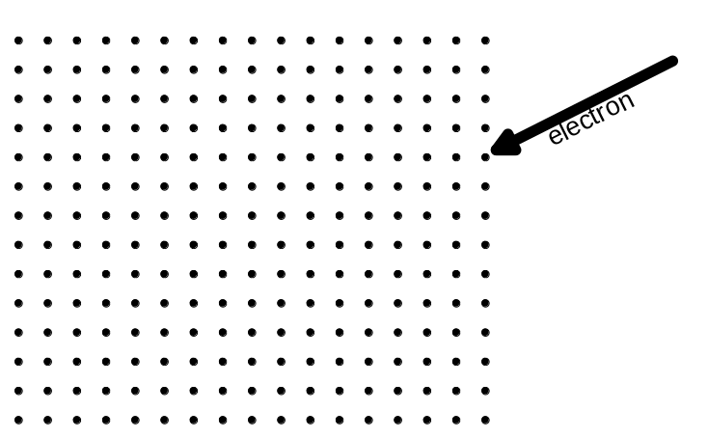
b) Bvq = mv²/r
∴r = mv/ Bq
= 9.11 x 10⁻³¹ x 2.6 x 10⁵ / 230 x 10⁻⁶ x 1.60 x 10⁻¹⁹
= 6.44 x 10⁻³ m (6.44 mm)
12. The device increases the available moment (leverage) by providing a larger radius
arm.

13. At low voltages, higher currents are needed to provide power to appliances, such as light globes. Higher currents involve greater losses of electrical energy due the resistance of the conducting wires (P_{loss} = I²R). Therefore the transformer needs to be close to the globe to reduces losses. Also, if several globes were connected to the same transformer, there would be a very large current drawn from that transformer which would increase internal losses (increasing with the square of current) in the transformer due to eddy current formation.

14. The toothbrush and holder are two parts of a transformer linked by magnetic flux only. i.e. Primary coil is in holder, secondary coil is in toothbrush, ∴current is induced in toothbrush which can charge the batteries.

15. a) A (or C), b) A, c) C (or A if down +ve), d) D

Section B
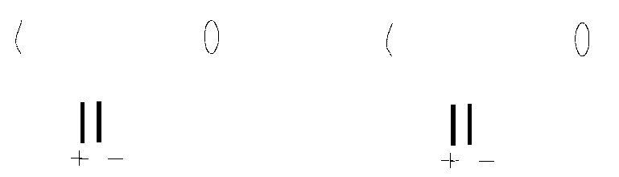

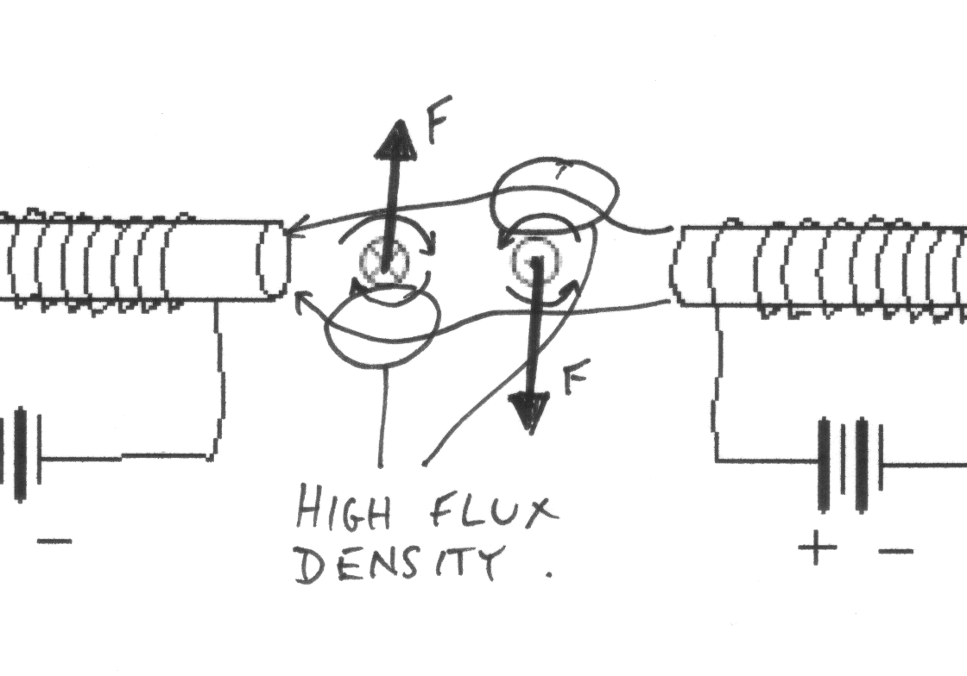
    - The regions of high magnetic flux density produce a clockwise moment about a central axis (if there was one). i.e. the motor effect

    - The commutator and brushes ensure that the side of the coil near a particular magnetic pole has its current in a consistent direction, thus enabling a constant spinning of the motor.
    - eg: more turns on the coil, more sets of coils and commutators to produce more uniform torque, electromagnets for magnetic field, radial magnetic field etc.
    - Maximum. Force on each side of the coil is perpendicular to the radius arm (i.e. the coil).

    - P = VI
∴ I = P/V
= 350/36
= 9.72 A
    - Torque = nBAI
∴0.78 = 250 x B x (0.1 x 0.1) x (0.7 x 9.72)
∴ B = 0.0459 T

  - Want horizontal velocity of car to equal velocity of truck.
∴ 6.0 cosθ = 3.5
∴ θ = 54.3°
  - For vertical direction:
s = ut + ½ at²
-0.58 = 6.0 sin 54.3° x t + 0.5 x (-9.81) x t²
∴ t = 1.101 s
For horizontal distance:
range = u_{h} x t
= 3.5 x 1.101
= 3.85 m
θ
  - v_{h} = 3.5 m s⁻¹
v_{v} = u_{v} + at
= 6.0 sin 54.3° + (-9.81)1.101
= -5.93 m s⁻¹
V² = 3.5² + (-5.93)²
∴ v = 6.89 m s⁻¹
tan θ = 5.93/3.5
∴ θ = 59.5°
∴ final velocity of car (relative to ground) is 6.89 m s⁻¹ declined 59.5 °
below horizontal.
3.5 m s⁻¹
-5.93 m s⁻¹

  - 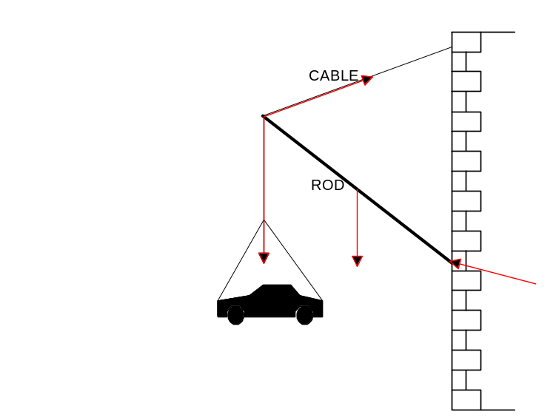
  - Take M about point where rod pivots at wall:
ΣCM = ΣACM
T x r x sin 60° = 2500 x 9.81 x r x sin 50° + 115 x 9.81 x r sin 50°
∴ T = 2.27 x 10⁴ N (note length of rod ‘r’ cancelled)
  - Consider equilibrium at free end of rod.
70º
2.27 x 10⁴ N
2.45 x 10⁴ N
C
C² = (2.27 x 10⁴)² + (2.54 x 10⁴)² – 2 x 2.27 x 10⁴ x 2.54 x 10⁴ cos 70º
∴C = 2.71 x 10⁴ N
  - ∴ ΔL = 9.67 x 10⁻⁴ m (0.967 mm)
  - T, and therefore strain, would have been greater because if the rod was horizontal, the cable would need to provide all of the vertical force to oppose the weight of the car and the rod. i.e. in the current position, the rod has an upward vertical component which it would no longer have it were horizontal.

  - GMm/r² = mv²/r
substituting v = 2πr/T, rearranging and simplifying gives:
M = 4π²r³/GT²
  - M = 4π²(9.35 x 10⁶)³/6.67 x 10⁻¹¹ x (2.73 x 10⁴)²
= 6.49 x 10²³ kg
  - g = GM/r²
= 6.67 x 10⁻¹¹ x 6.49 x 10²³/(3.43 x 10⁶)²
= 3.68 m s⁻²
  - v = 2πr/T
= 2 x π x 9.35 x 10⁶/2.73 x 10⁴
= 2.15 x 10³ m s⁻¹ (2 150 m s⁻¹)
  - YES, is has centripetal acceleration towards Mars.
  - T = 1.024 x 24 x 3600
= 8.84 x 10⁴ s
from part (a) above, it can be shown that:
r³ = MGT²/4π²
∴ r = 6.49 x 10²³ x 6.67 x 10⁻¹¹ x (8.84 x 10⁴)²/4 x π²
= 2.05 x 10⁷ m
  - F_{R} = mv²/r – mg
= 75 x 69.4²/512 – 75 x 3.68
= 430 N

    - The lines are emission lines, produced when excited electrons fall back to lower energy levels emitting a photon of light.
    - E = hf and 1 eV = 1.60 x 10⁻¹⁹ J and c = fλ,
∴E = hc/(λ x 1.60 x 10⁻¹⁹)
∴E₁ = 6.63 x 10⁻³⁴ x 3.00 x 10⁸/(589.0 x 10⁻⁹ x 1.60 x 10⁻¹⁹) = 2.111 eV
& E₂= 6.63 x 10⁻³⁴ x 3.00 x 10⁸/(589.6 x 10⁻⁹ x 1.60 x 10⁻¹⁹) = 2.108 eV
∴spacing = 2.111 – 2.108 = 2.57 x 10⁻³ eV

    - The incoming electrons have transferred some of their E_{k} to the ground state electrons in the sodium atoms. They are accelerated to different energy levels and therefore, not all incident electrons lose the same amount of energy.
    - Energy lost by incident electrons is 2.1 eV and 3.2 eV
∴ based on given data only, part of the energy level diagram would be:
0
2.1 eV
3.2 eV
    - Highest energy photon would be 3.2 eV = 5.12 x 10⁻¹⁹ J
λ = hc/E
= 6.63 x 10⁻³⁴ x 3 x 10⁸ / 5.12 x 10⁻¹⁹
= 3.88 x 10⁻⁷m (388 nm)
  - X-rays are produced by accelerating electrons with a high voltage and allowing them to collide with a metal target. X-rays are produced when the electrons are suddenly decelerated upon collision with the metal target; these x-rays are commonly called brehmsstrahlung or "braking radiation". If the bombarding electrons have sufficient energy, they can knock an electron out of an inner shell of the target metal atoms. Then electrons from higher states drop down to fill the vacancy, emitting x-ray photons with precise energies determined by the electron energy levels. (or words to that effect!!)

    - A
    - 1/0.02 = 50 Hz
    - Time for ¼ of a revolution = 0.005 s
emf = NΔΦ/t
∴ 350 = 500 x ΔΦ/0.005
∴ ΔΦ = 3.50 x 10⁻³ Wb
    - Advantages: Stronger magnetic field possible, ∴ great emf possible. Don’t “wear out” like permanent magnets.
Disadvantages: Main disadvantage is “cold starts” are not possible without an external power supply to excite the stator windings. Western Power have a bank of batteries for this purpose. Once the generator is operating, it can provide its own current for the stator windings. Also, as some current is used for stator windings, less current is available for external circuit.

    - Large eddy currents are induced in the core of the transformer, these dissipate heat, which needs to be removed to prevent the transformer from overheating.
    - 350 : 142 000
1 : 406
    - Voltage is stepped up to lower transmission current. Power lost in transmission lines due to their resistance is I²R, therefore it is critical to keep current down to a minimum.

Section C

              - An echo is a reflection that can be distinguished as being separate from the original sound.
              - Late reflections can backfill the 1/8 second periods of silence between syllables, causing individual syllables to slur together and reduce clarity.
              - They can be converted to early reflections, absorbed or diffused.
              - A reverberation is not heard as a separate sound. Reverberation is a prolonged series of reflections that are very close together and cause the sound to “last longer”. Reverberations take between 2 and 5 seconds to fade away. An echo arrives at our ear more than 60 ms later than the direct sound is therefore heard as a separate sound.
              - Early reflections arrive within 60 ms of the original sound. Therefore our ears do not distinguish two separate sounds. Instead, the early reflection adds to the original sound, making it louder.
              - Ceilings and sidewalls can be fitted with objects that create early reflections, for example rounded soffits, hollow pillars etc. The auditorium can be fitted with an acoustical cloud to scatter sound back down to the audience area (The Perth Concert Hall has a very obvious acoustical cloud above the main audience area.). Early reflections can also be faked by adding a distributed sound system that produces secondary sounds 5 dB quieter than the originals and 50 ms later.

              - Durability is also a requirement. Ceramics are brittle and therefore entirely unsuitable for pole vaulting. Also carbon fibre composite materials resist twisting.
              - An outer layer of high-strength carbon fibre providing high stiffness and an intermediate webbing of fibres together with an inner layer of wound-glass fibre building resistance to twisting.
              - Tension, compression, bending, and torsional stresses.

              - For example:
C
T
B

              - Steel is heavy and corrodes.

              - The article asserts that the use of advanced materials and improved aerodynamics (in cycling) have added greatly to the results that have been achieved in these sports.

              - Bicycles must lean as they take corners, so that the reaction force from the road has a horizontal component to provide centripetal force. Bike tyres are curved so that when the bike leans around a corner, there is still plenty of tyre in contact with the ground.

